**Dr.Babasaheb Ambedkar Marathwada**

**University, Chhatrapati Sambhajinagar**



**Project Report**

**On**

**“Ice Cream Delights”**

**Guided By**

**Dr. Almas Siddiqui**

**Presented By**

**Dhanashree Govind More**

**Submitted To**

**VIVEKANAND INSTITUTE OF ADVANCED STUDIES IN MANAGEMENT SCIENCE & COMMUNICATIONS,**

**CHHATRAPATI SAMBHAJINAGAR.**

**2023-2024**

**Vivekanand Shikshan Sanstha’s**



**VIVEKANAND INSTITUTE OF ADVANCED STUDIES IN MANAGEMENT SCIENCE & COMMUNICATIONS, CHHATRAPATI SAMBHAJINAGAR.**

**CERTIFICATE**

This is to certify that the project report on **“Ice Cream Delights”** In the subject of Environment science, has been successfully completed and submitted by **Dhanashree Govind More Roll** **NO : 17** as requirement of **Dr. Babasaheb Ambedkar Marathwada University Chhatrapati Sambhajinagar,** in partial fulfillment of **Masters of Science (Computer Science) Ist/IInd Year for academic year 2023-2024.**

***(Guided By) Examiner (Head of Dept)***

**Dr. Almas Siddiqui Dr. A.T.Gaikwad**

***ACKNOWLEDGEMENT***

Firstly I express my gratefulness to **Dr. Almas Siddiqui** is my teacher of Environment Science of Vivekanand Institute of Advanced Studies in Management Science & Communication, Chhatrapati Sambhajinagar. For her work supervision and valuable suggestions him thoughts providing guidelines, co-operation and extended help during this work of dissertation has made it possible to complete this piece of work. Her broad-based knowledge it this field and science oriented personality has been essentially, realized me appreciation and encouragement served as a constant.

I am thankful to our Incharge **Dr. Mangesh Rege** for his advice & suggestion throughout. I am also thankful ***Dr. A.T. Gaikwad,***  who encouraged and helped me throughout the in **“Ice Cream Delights”** project. Last but not the least, I would like to thank for the timely assistance and suggestion of numerous other faculty members, friends and parents.

**Submitted By-**

**Dhanashree Govind More**

***DECLARATION***

I hereby announce that this dissertation entitled “**Ice Cream Delights ”** is imaginative work carried out by me under the guidance of  **Dr. Almas Siddiqui** our teacher of Environment Science, Vivekanand Institute of Advanced Studies in Management Science & Communication, Chhatrapati Sambhajinagar. For fulfillment of the M.Sc.(Computer Science) First/Second Year course. This work has not been submitted or published anywhere in any other form of or dissertation.

**Submitted By**

**Dhanashree More**

**INDEX**

|  |  |  |
| --- | --- | --- |
| Sr.no | Name | Page no |
| 1 | Chapter 1 : INTRODUCTION | 6 |
| 2 | Chapter 2: Technology | 7 |
| 3 | Chapter 3 : Screen Layout | 8 |
| 4 | Chapter 4 : Code Structure | 18 |
| 5 | Chapter 5 : Conclusion | 28 |

**Introduction To Project**

Welcome to Ice Cream Delights, your ultimate destination for all things ice cream!

At Ice cream Delights, we believe that ice cream is more than just a dessert; it's a celebration of life's sweet moments. Our journey began with a simple mission: to create the most delicious, indulgent, and unforgettable ice cream experiences imaginable.

Our commitment to quality starts with the finest ingredients sourced from local farmers and producers whenever possible. From creamy dairy to luscious fruits and decadent chocolates, each ingredient is carefully selected to ensure the highest standards of taste and freshness.

But it's not just about the ingredients; it's about the artistry and passion that goes into every scoop. Our talented team of flavor experts and artisans work tirelessly to craft a diverse range of flavors that cater to every palate. From timeless classics like creamy vanilla and rich chocolate to adventurous creations like salted caramel pretzel and exotic fruit sorbets, there's something here to satisfy every craving and curiosity.

But our dedication to excellence doesn't stop at flavor. We're also committed to creating a welcoming and inclusive space where everyone can indulge in the simple pleasures of ice cream. Whether you're a lifelong aficionado or trying our flavors for the first time, you're always welcome here.

**Technologies Used**

The technologies used for the static website are:

HTML(Hypertext Markup Language): HTML is used for structuring the content of the website. It defines the layout and organization of the various elements on the page, such as headers, navigation menus, main content, and footer.

CSS(Cascading Style Sheets): CSS is used for styling the HTML elements. It defines the visual appearance of the website, including colors, fonts, spacing, and layout. In the provided code, a separate CSS file (styles.css) is linked to the HTML document to apply styles uniformly across the site.

JavaScript: JavaScript is used to add interactivity and dynamic behavior to the website. In the provided code, JavaScript is used to dynamically load content into the main area of the webpage when navigation links are clicked. It also handles events and interacts with the DOM (Document Object Model) to manipulate elements on the page.

These three technologies (HTML, CSS, and JavaScript) form the foundation of web development for creating static websites. They work together to create a visually appealing, interactive, and functional user experience on the web.

**Screen Layout :**

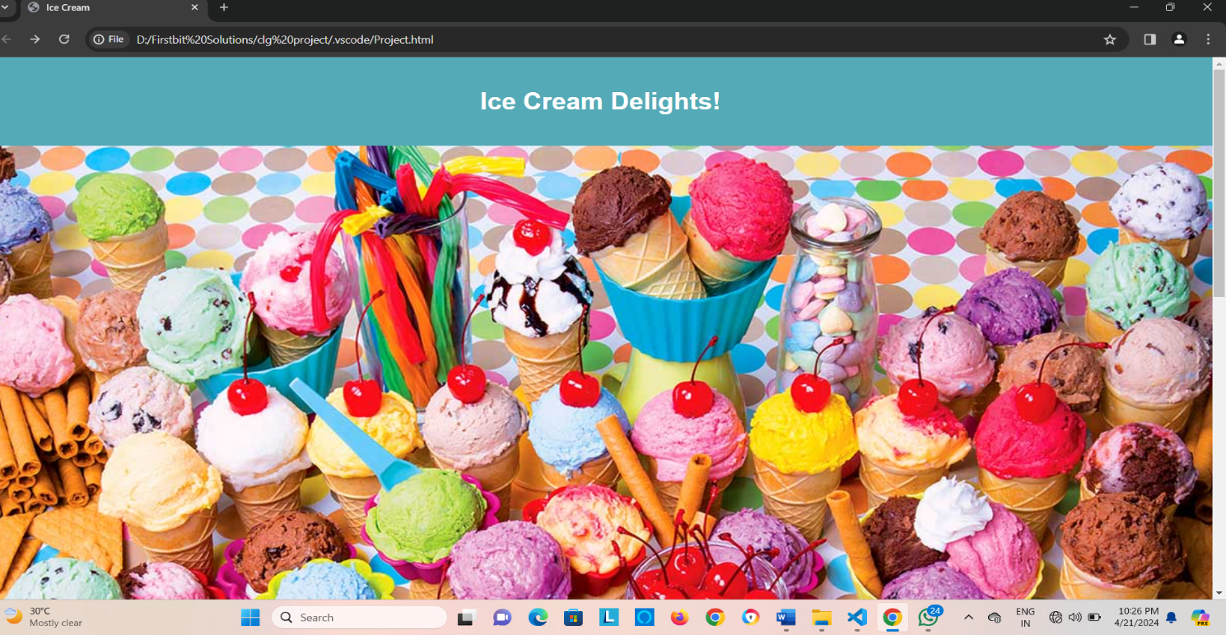

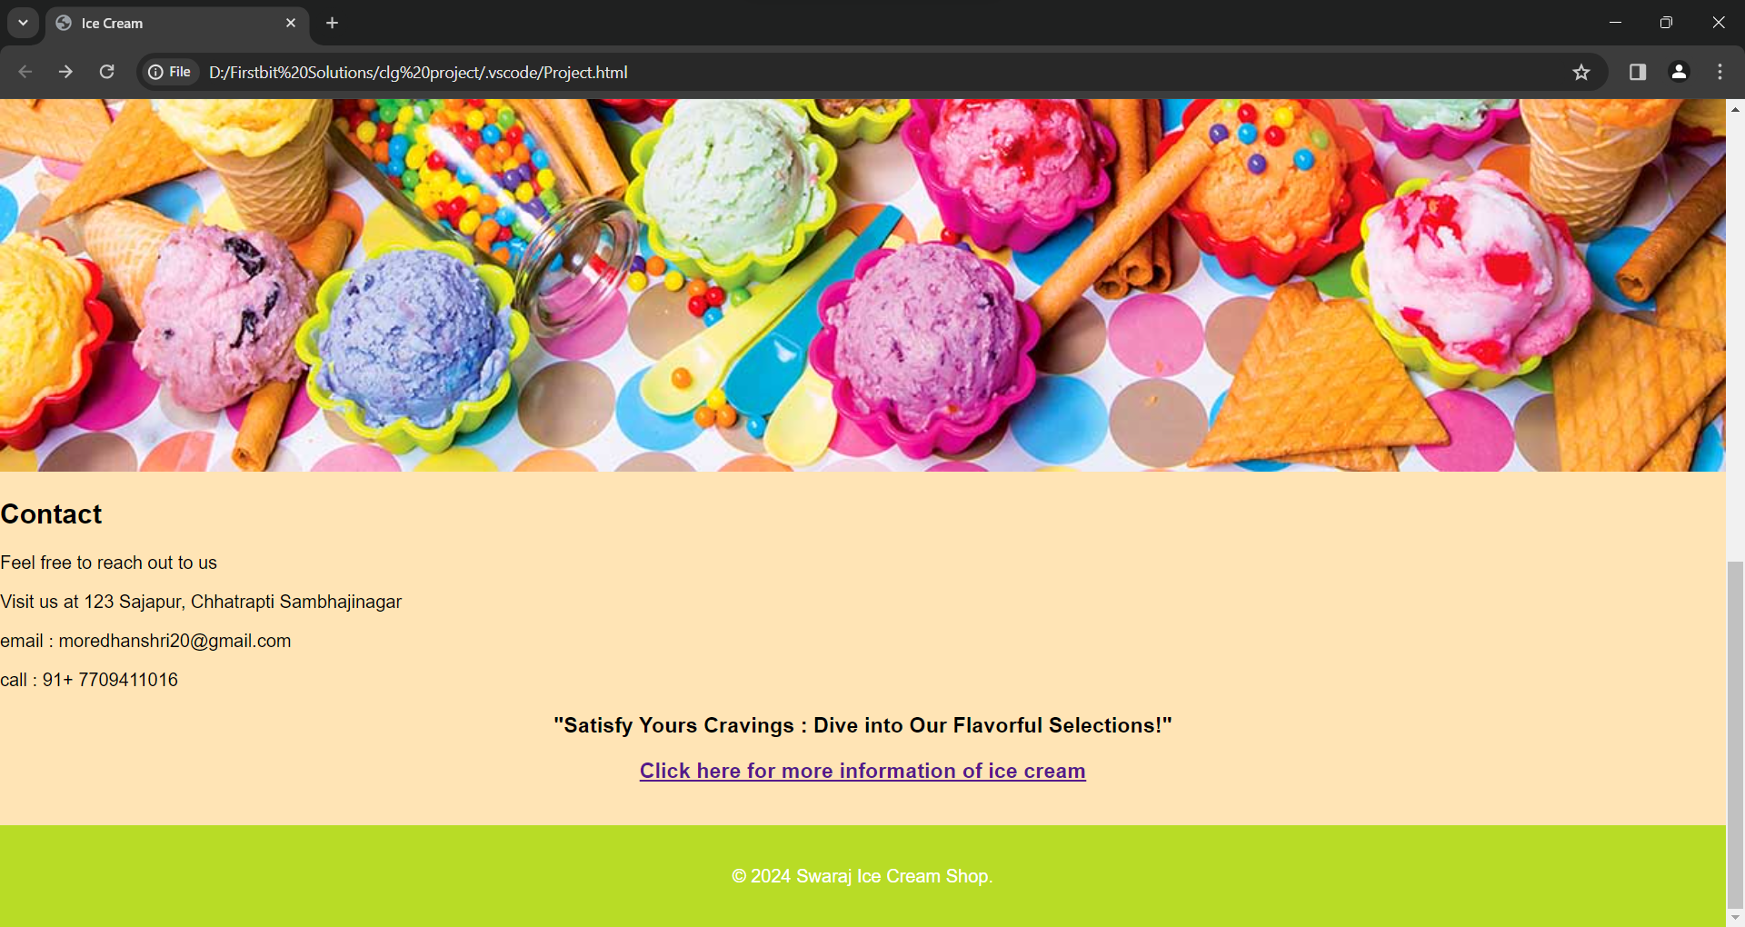

**Home Page :**

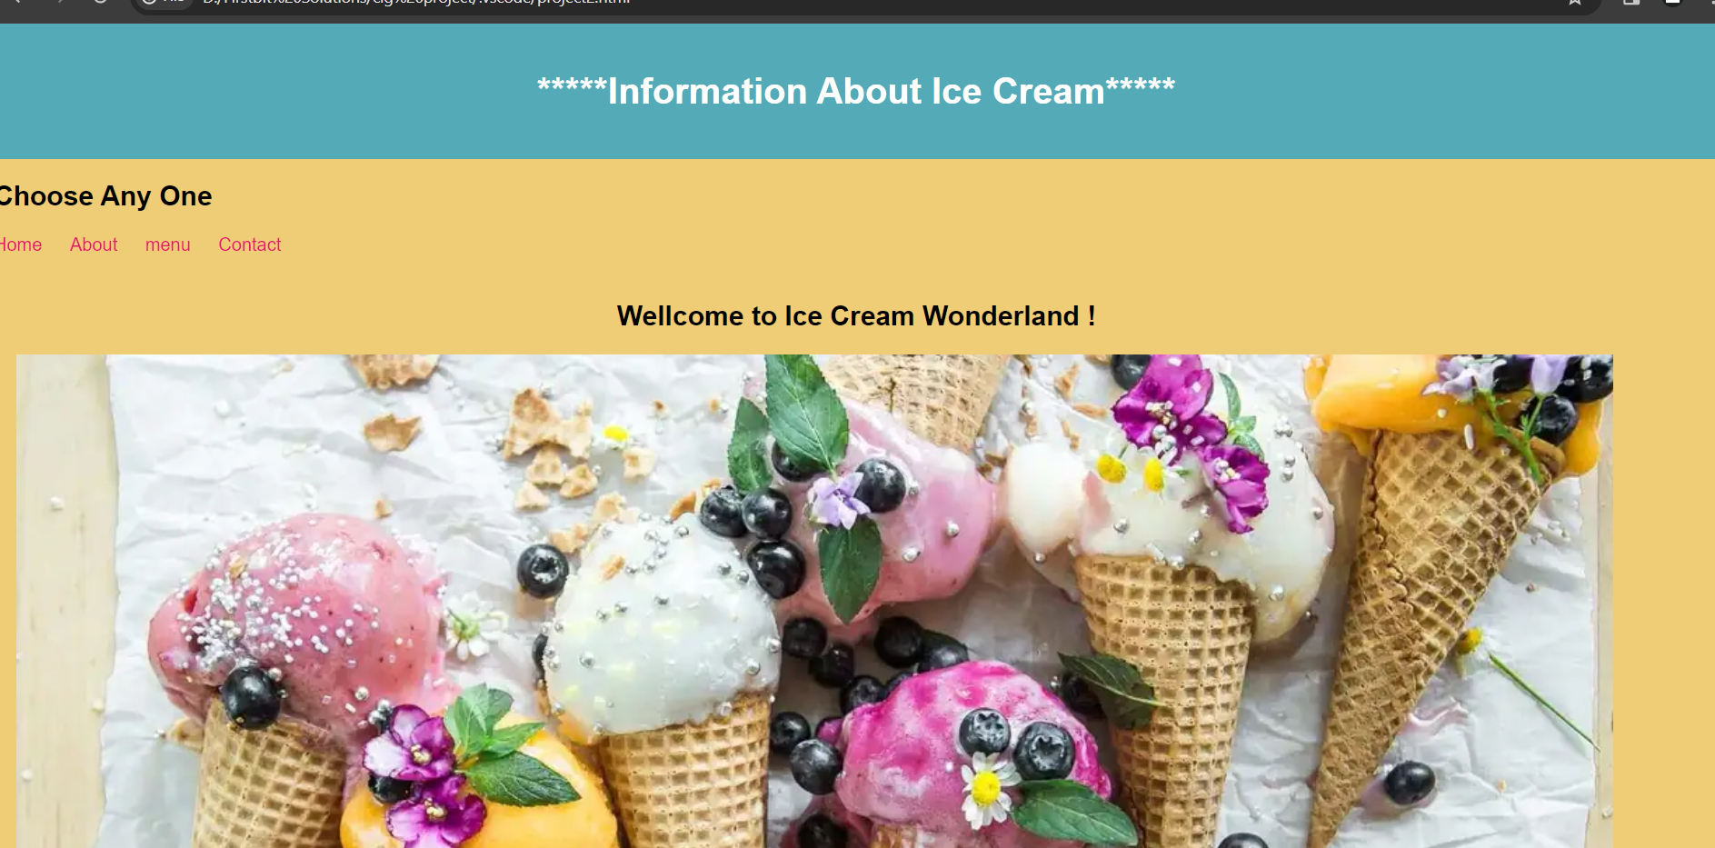

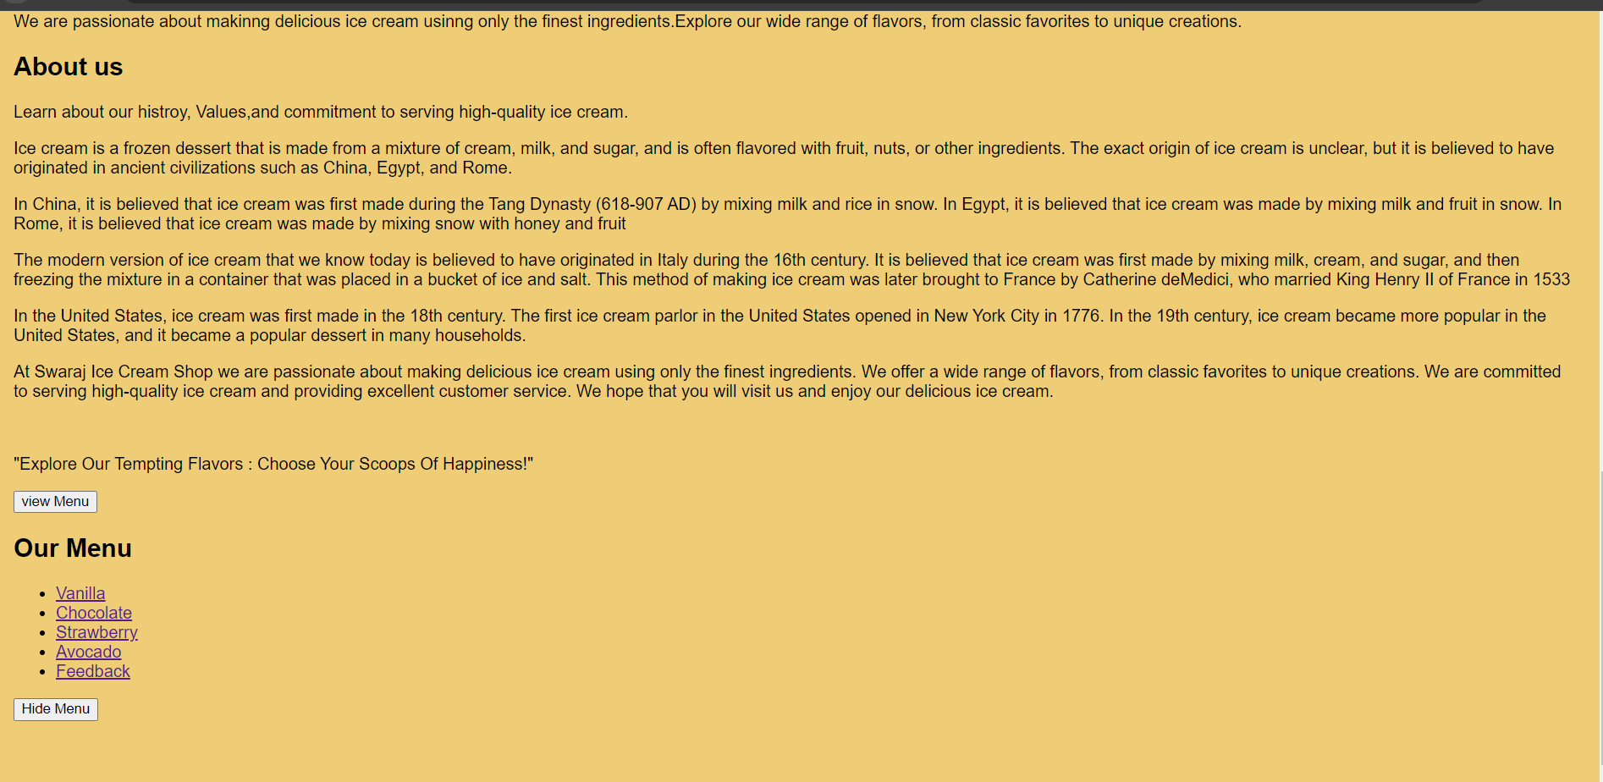

**Vanilla Ice Cream :**

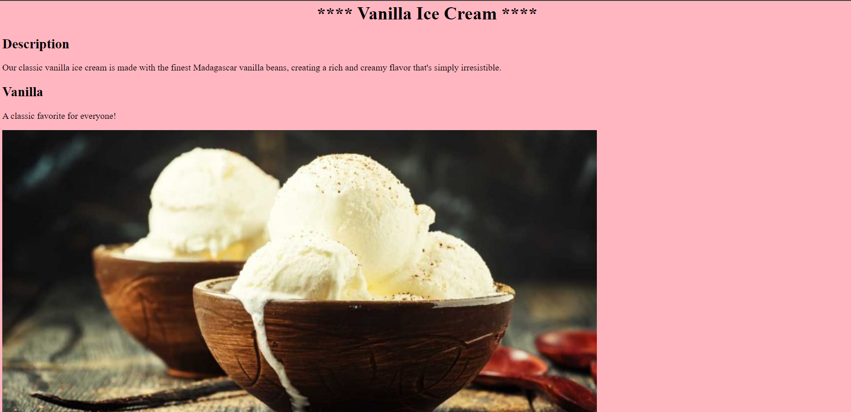

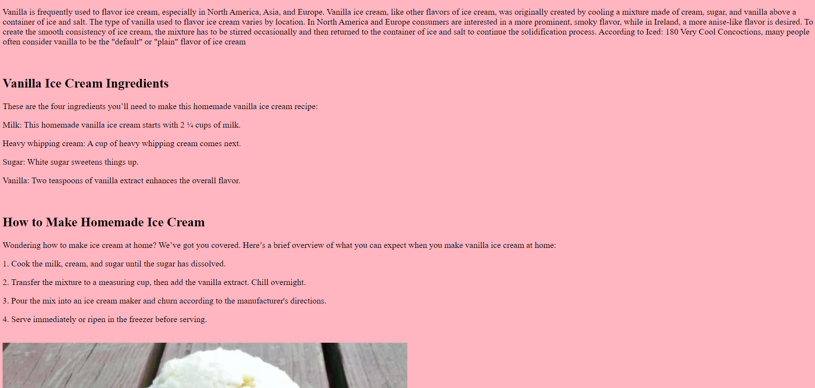

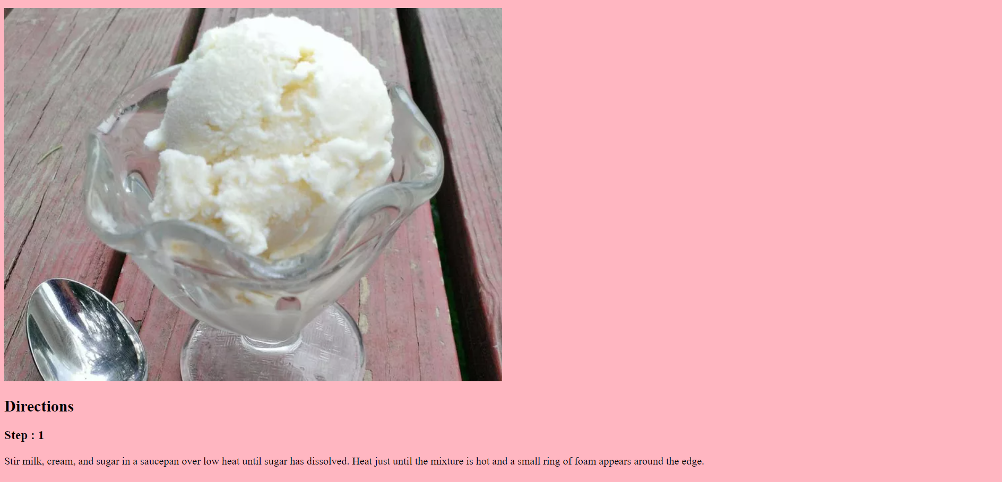

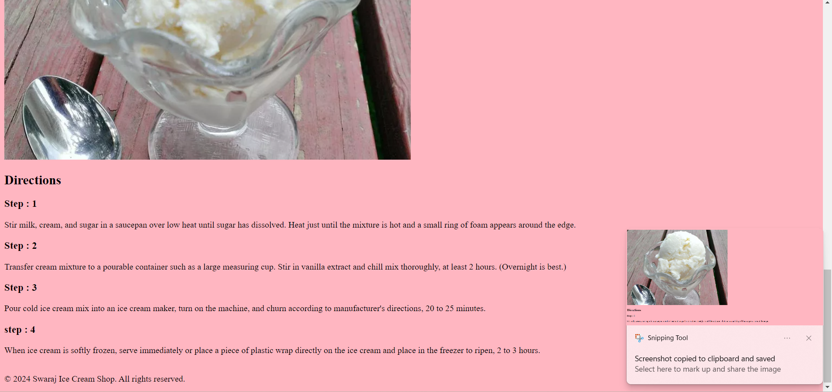

Chocolate Ice Cream :

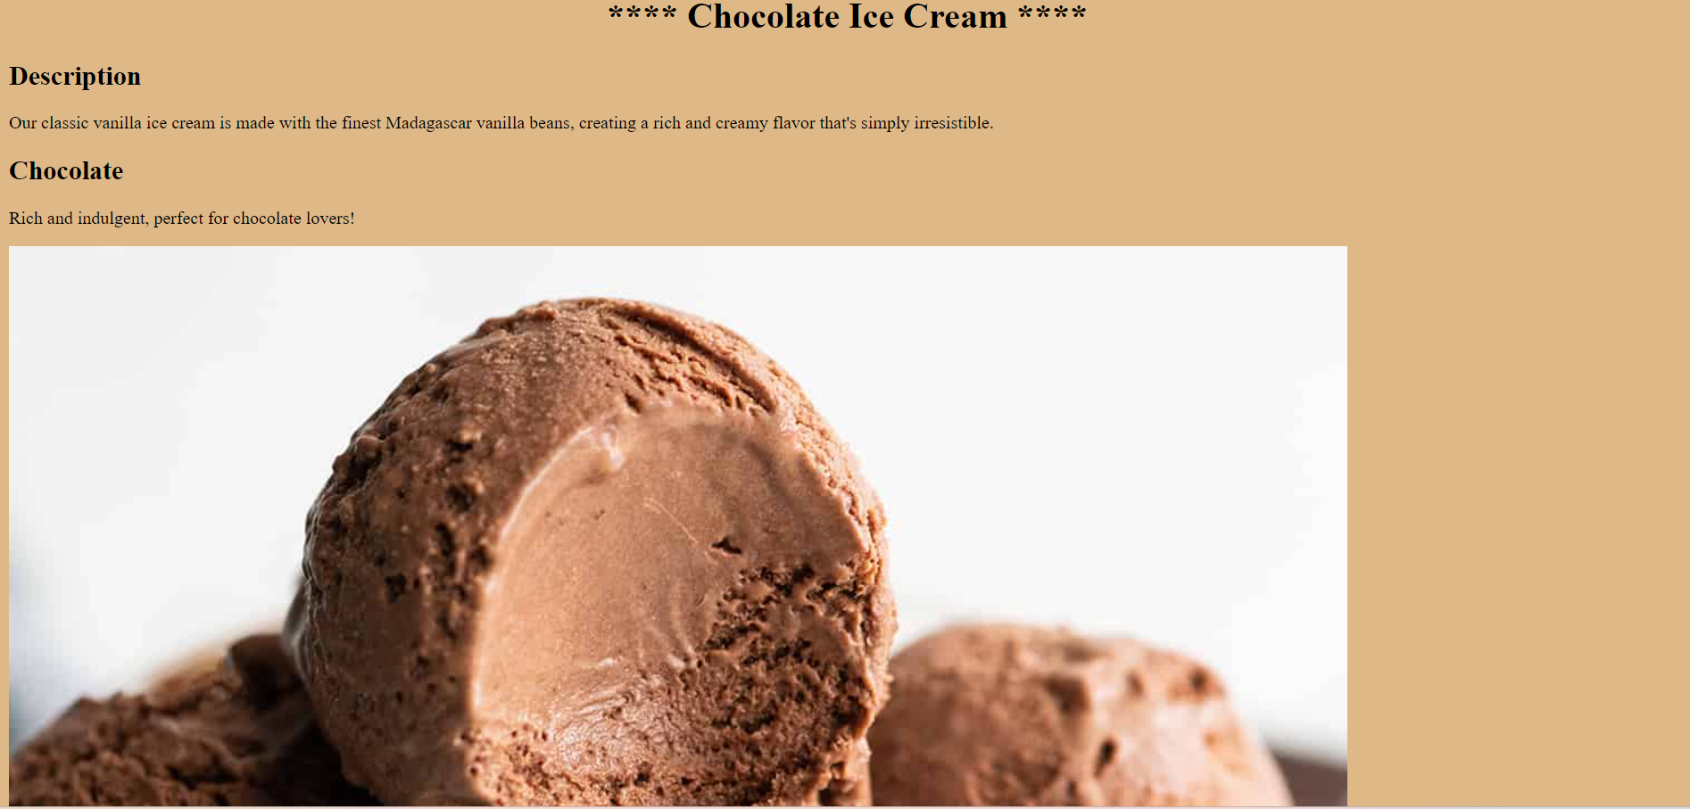

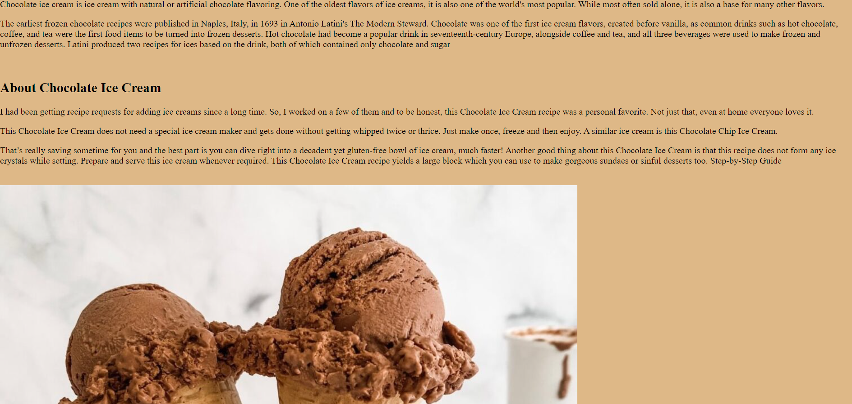

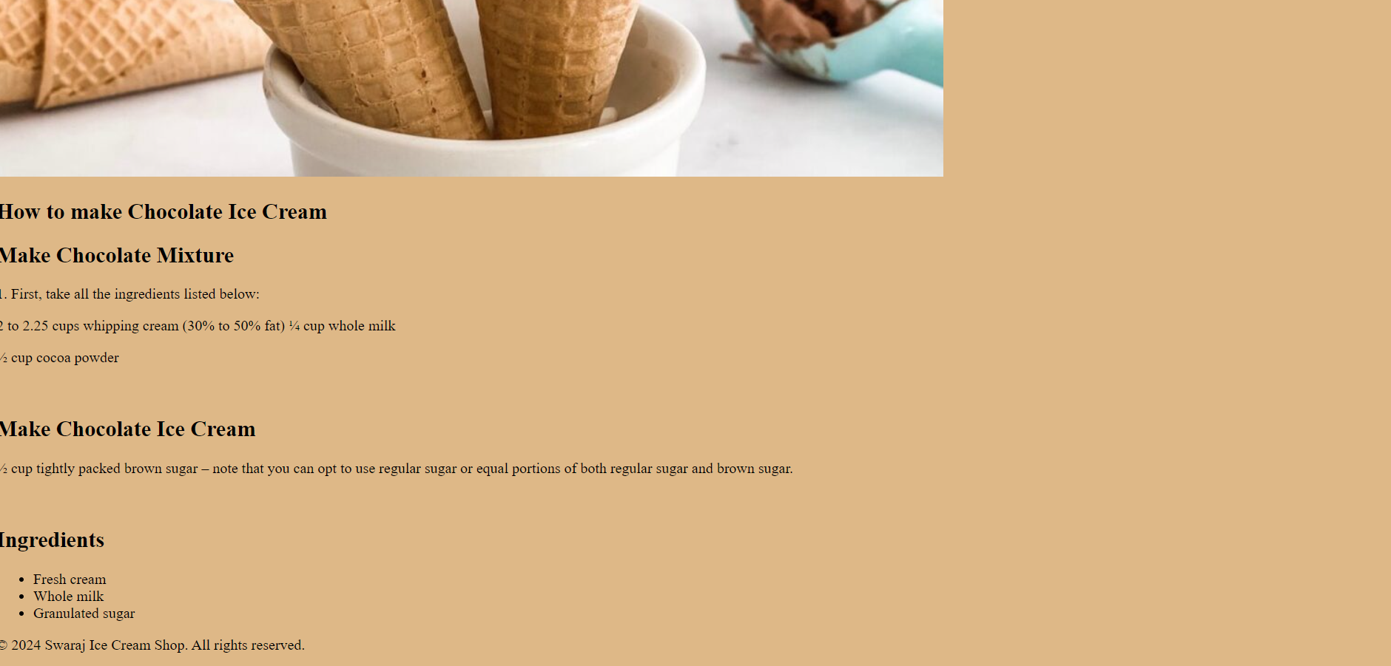

**Strawberry Ice Cream**

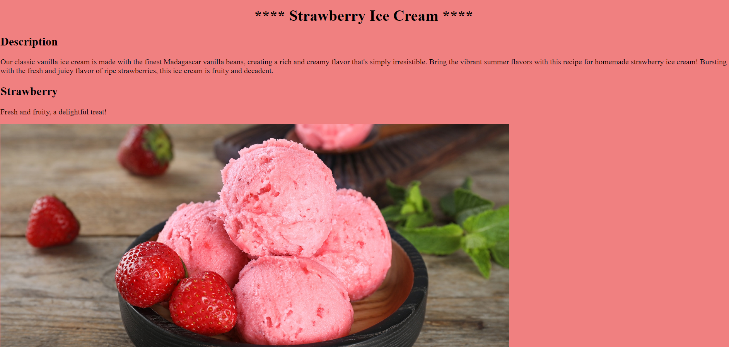

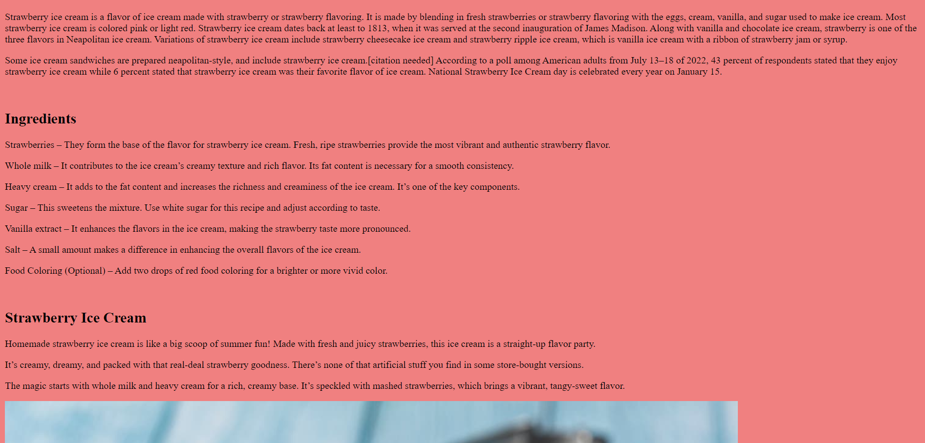

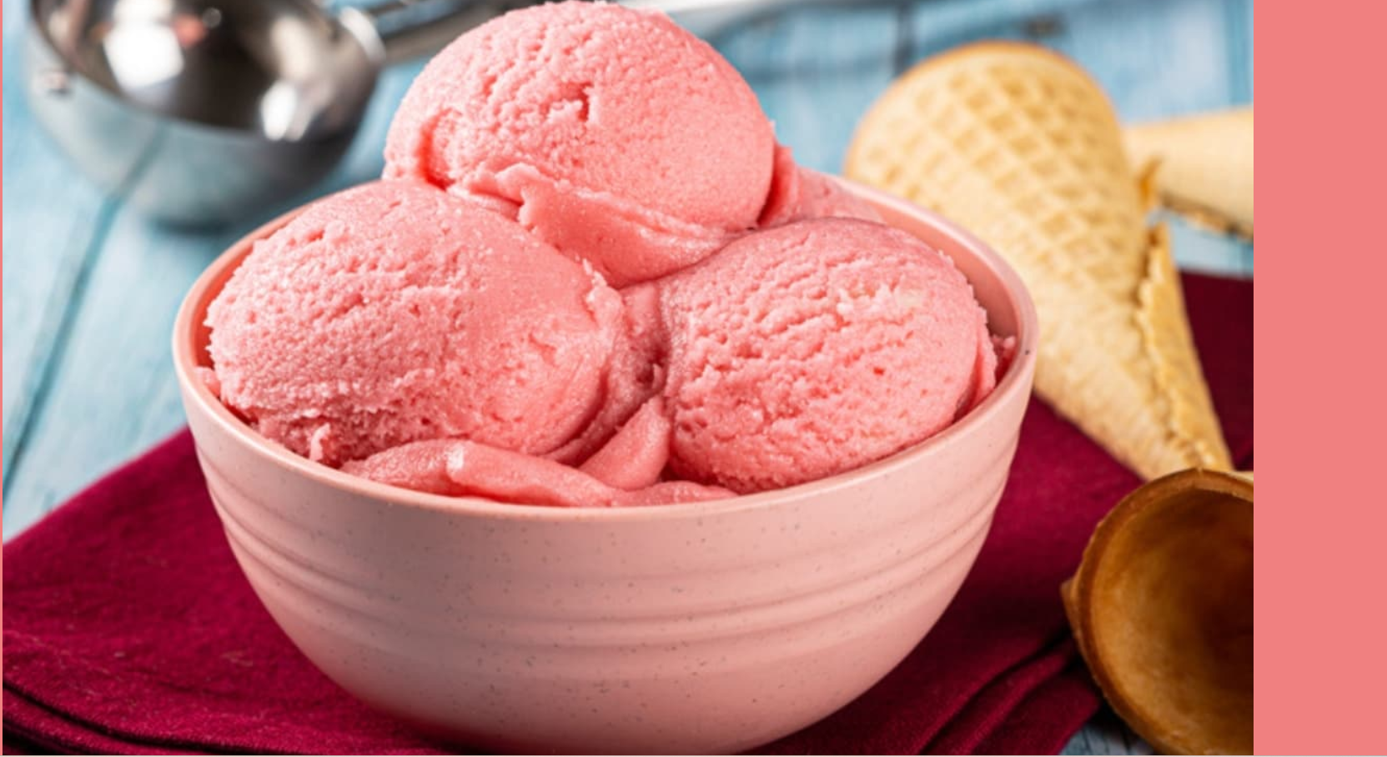

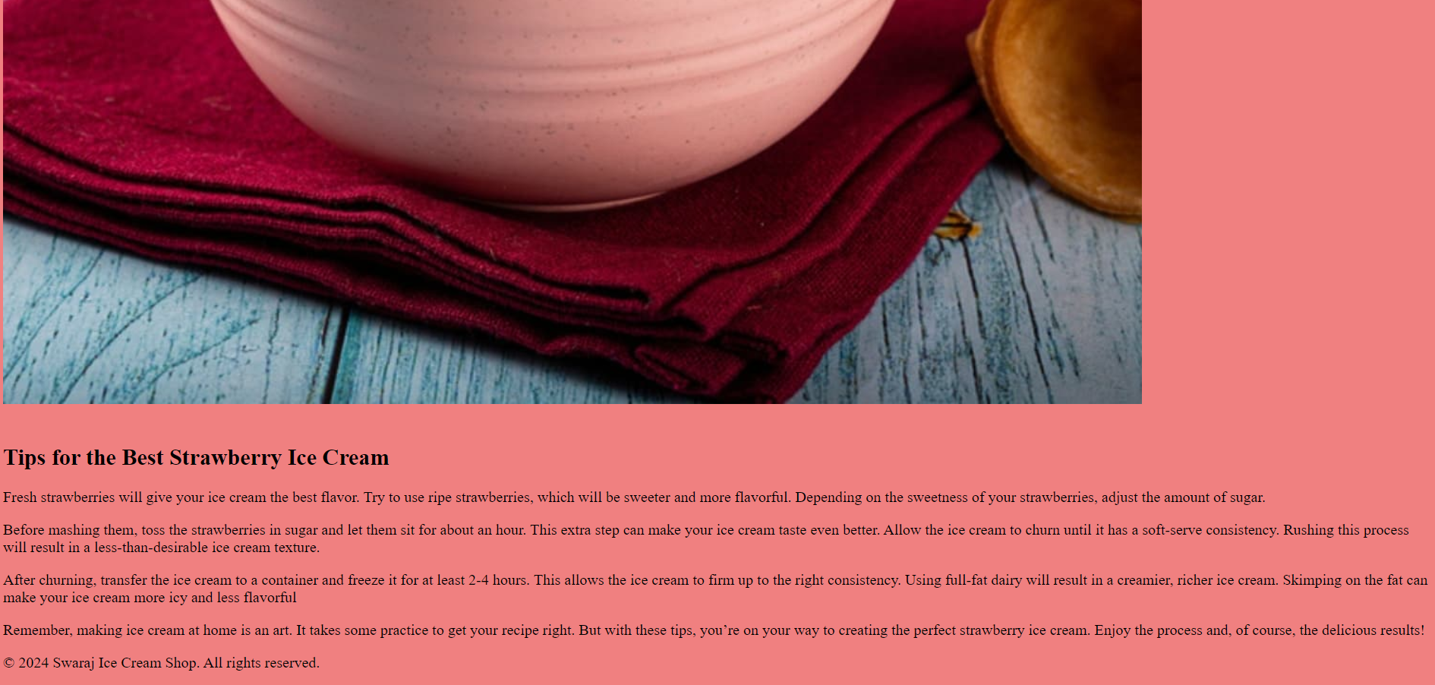

**Avocado Ice Cream**

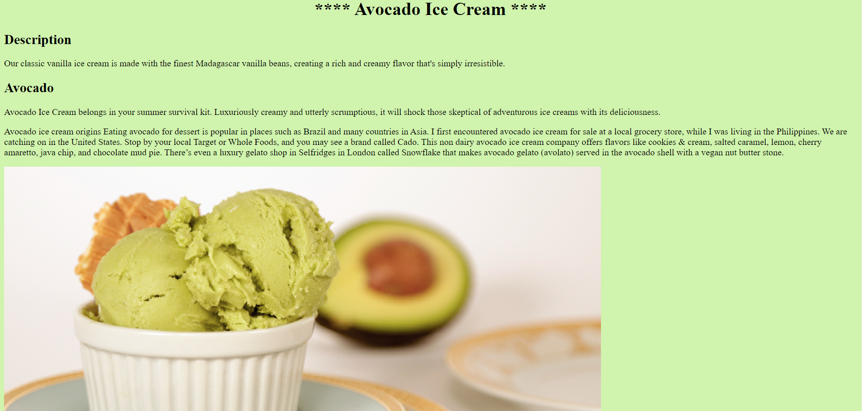

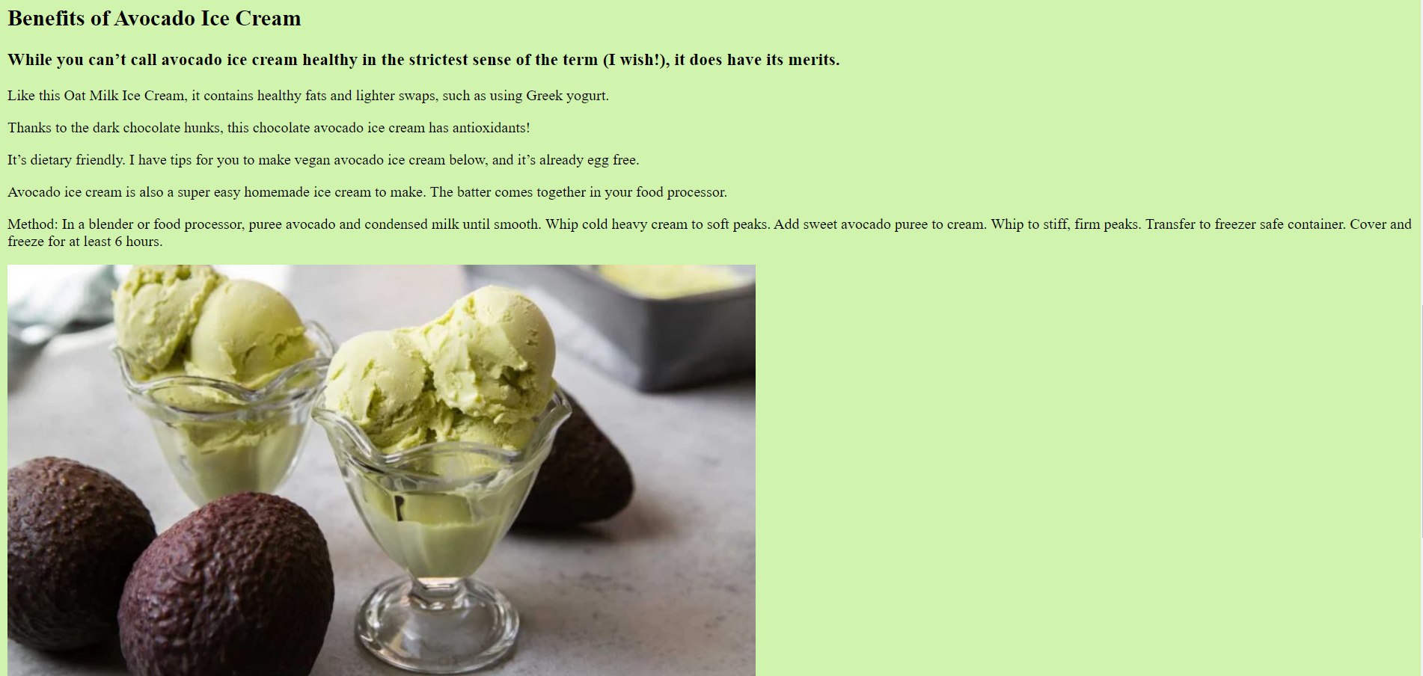

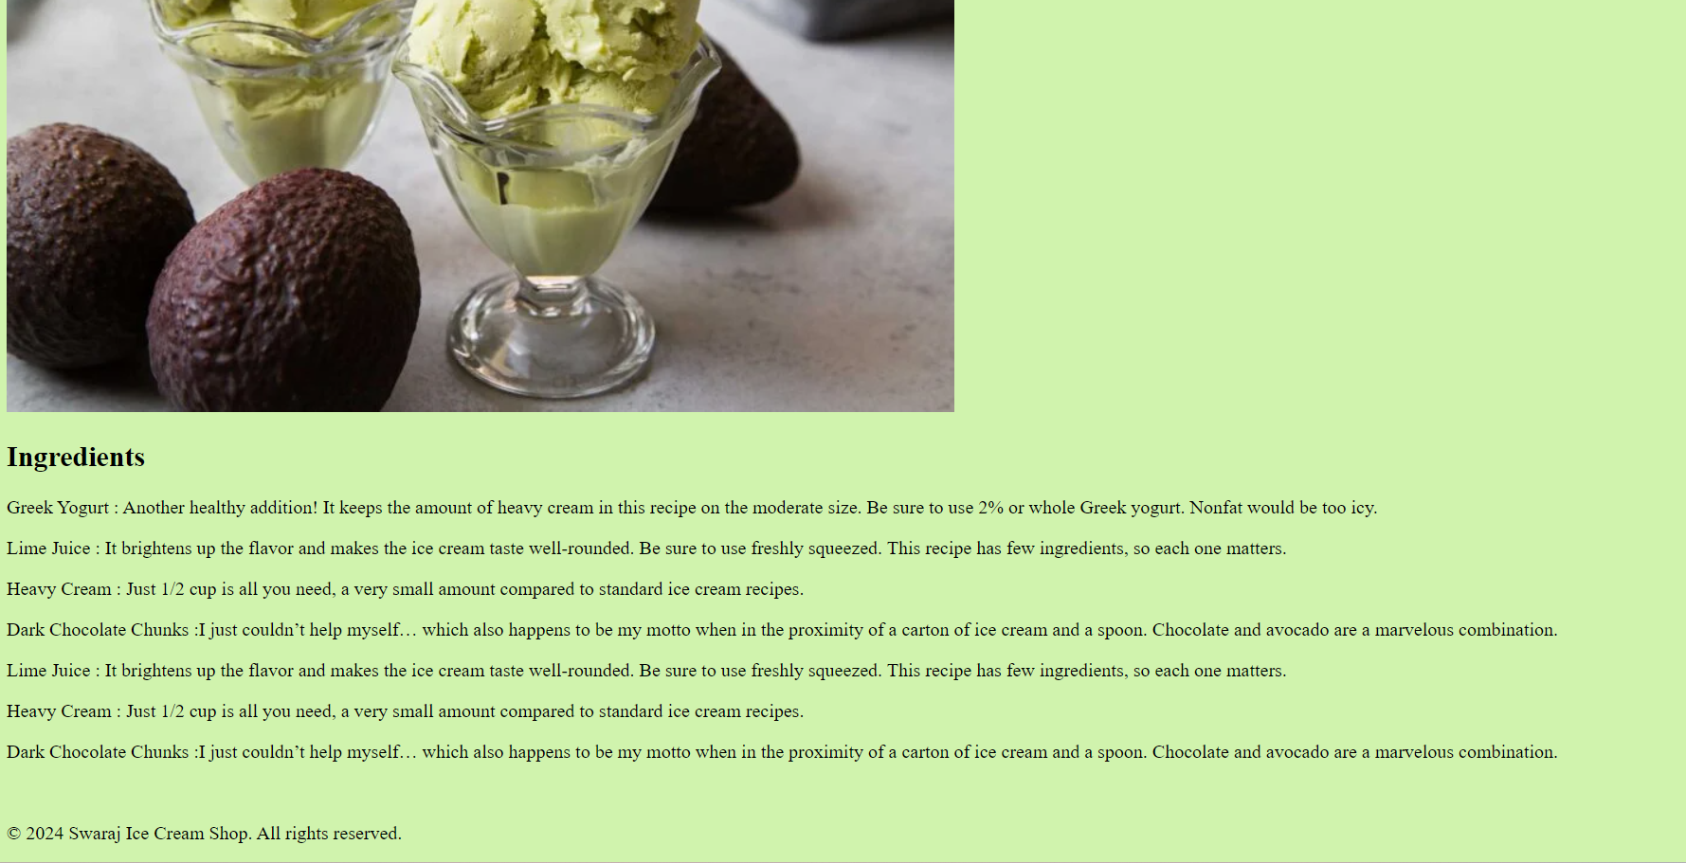

**FeedBack Form :**

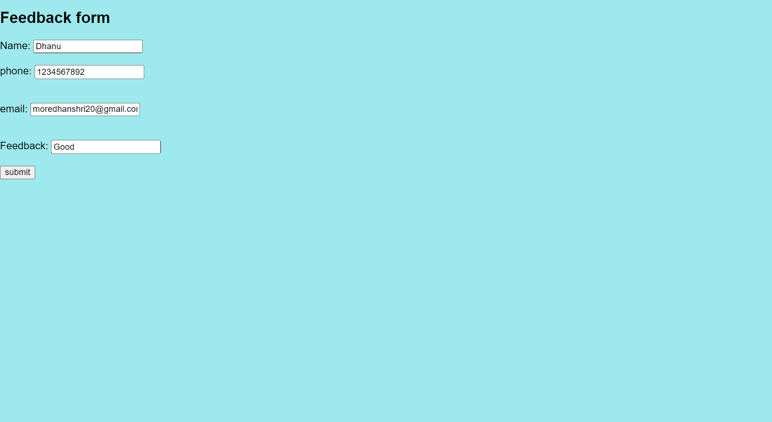



**Code Structure**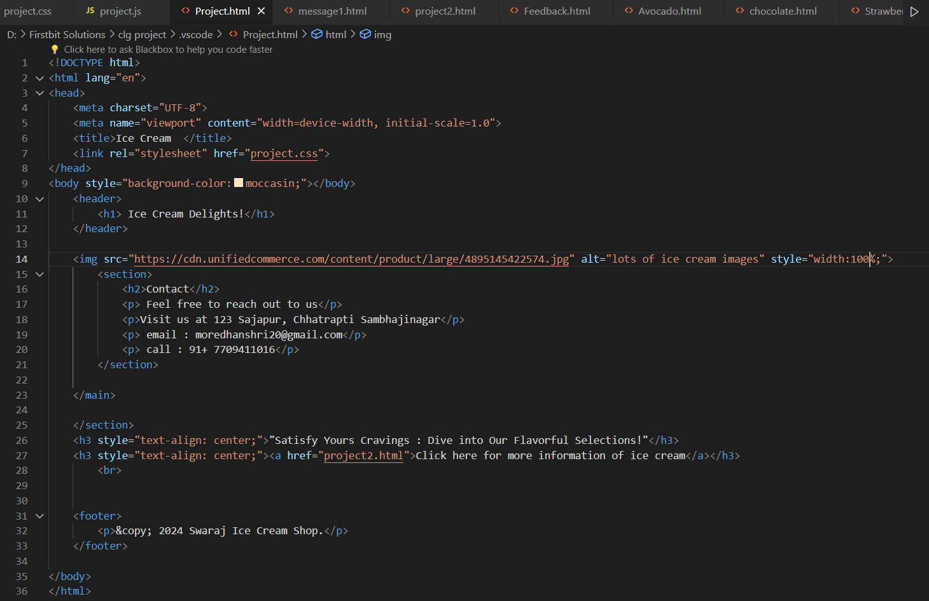

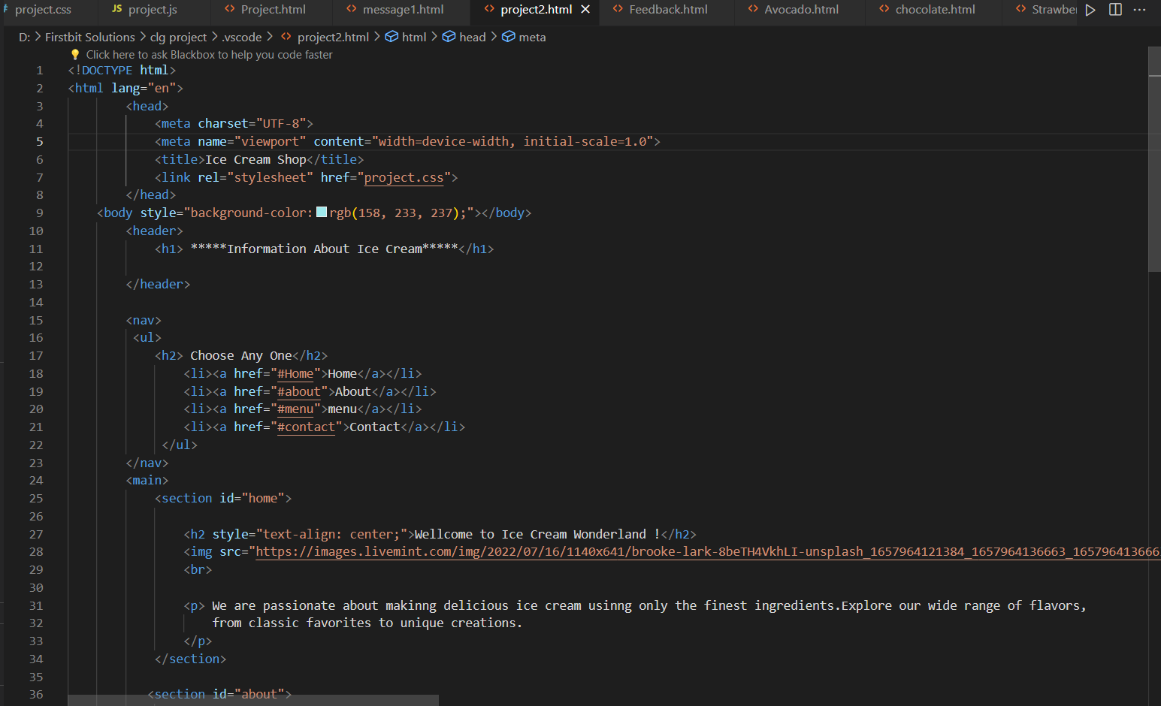

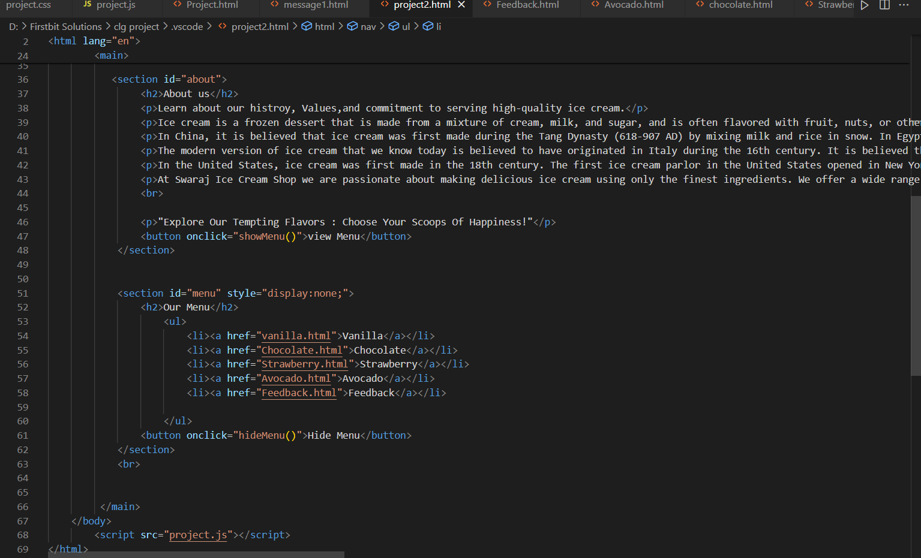

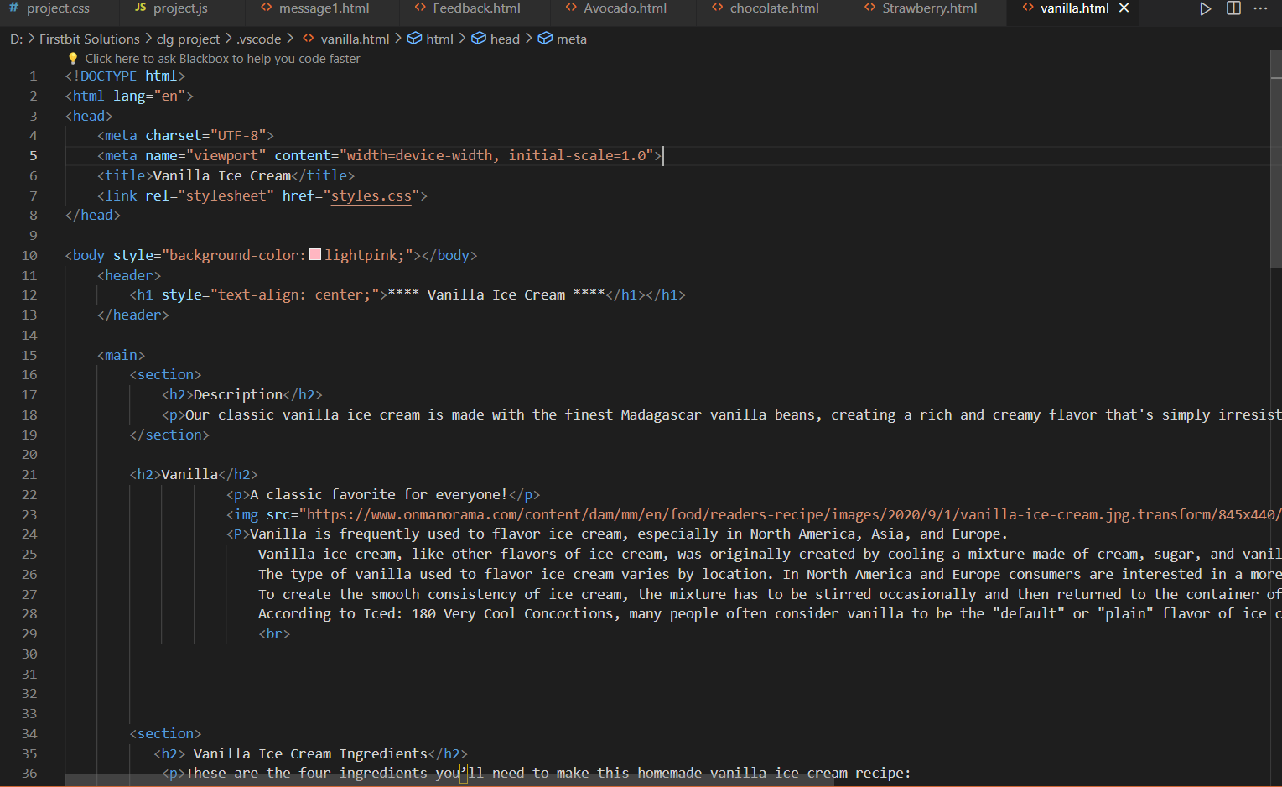

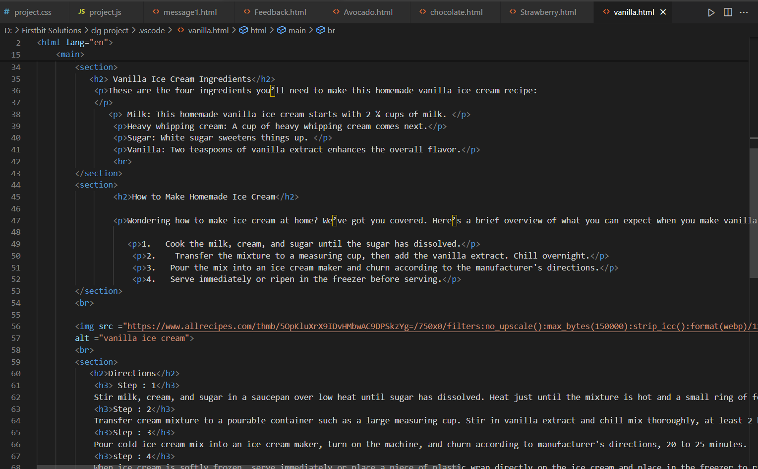

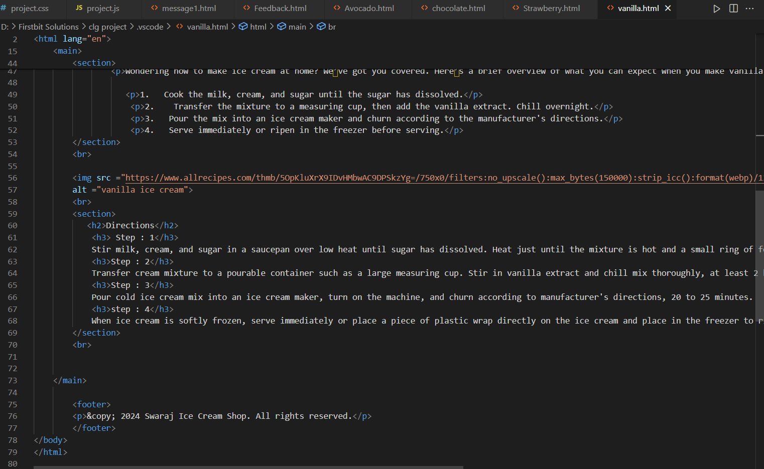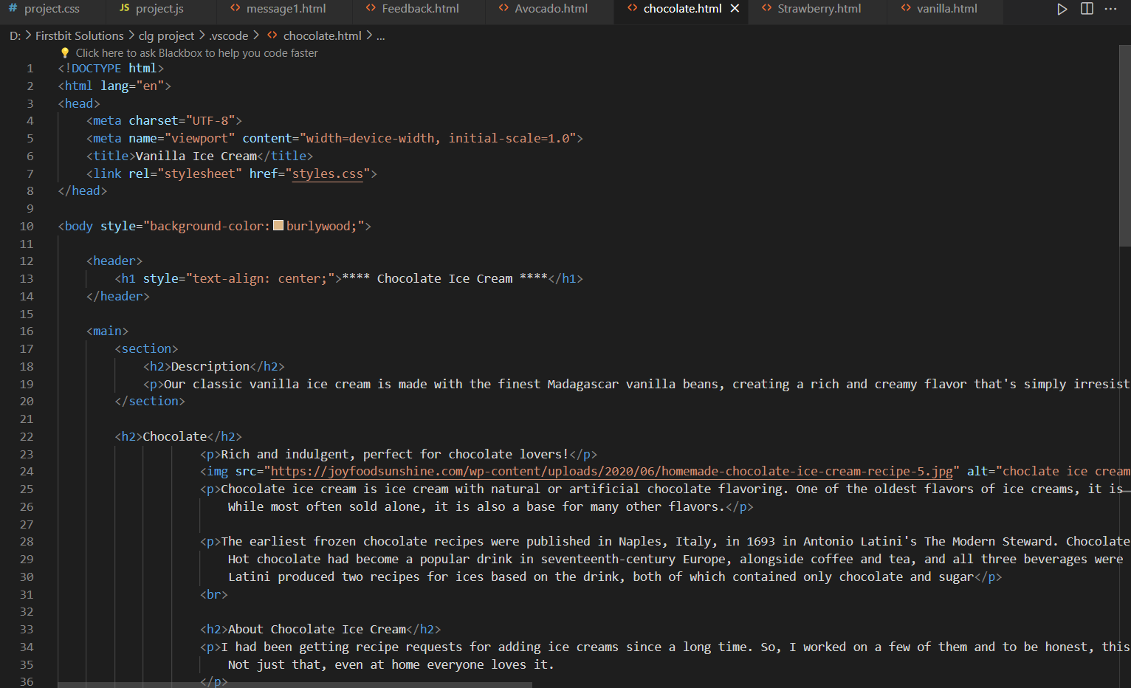

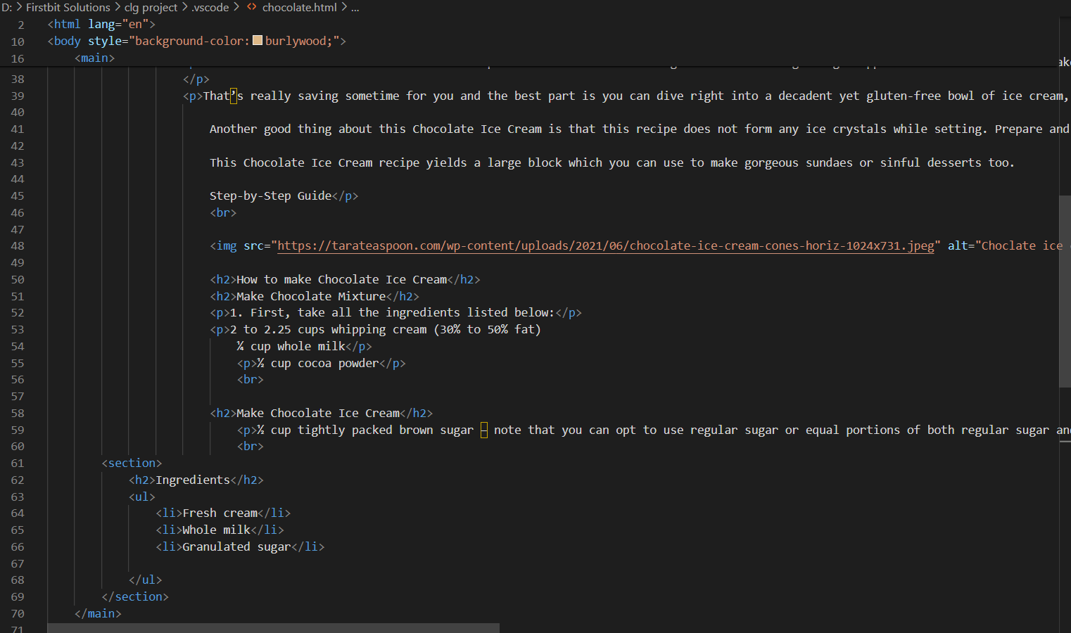

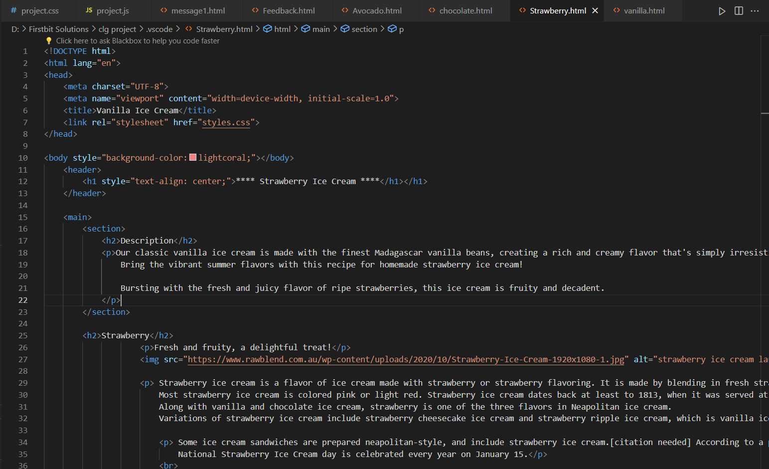

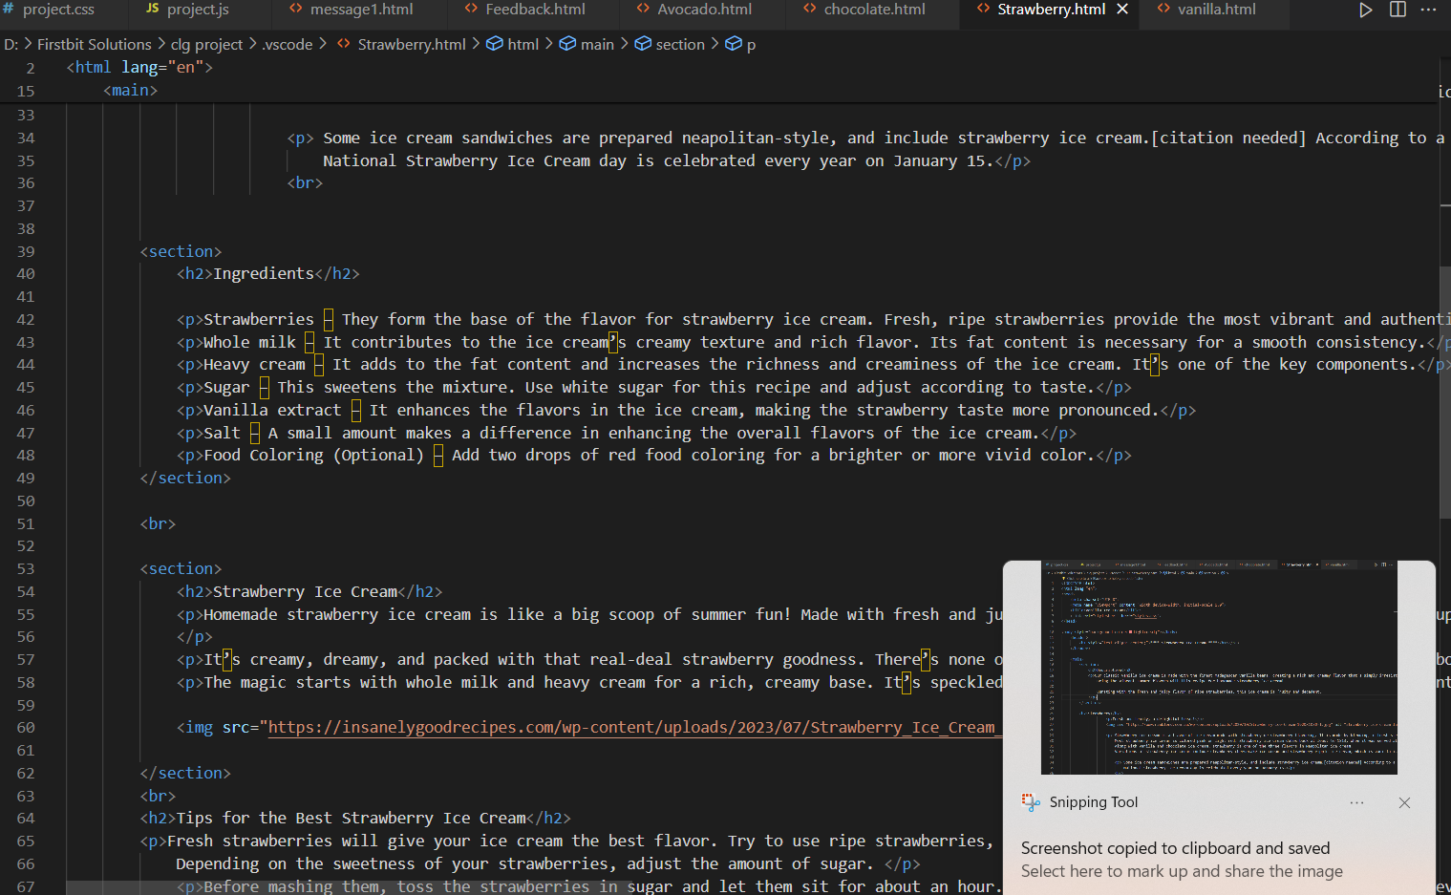

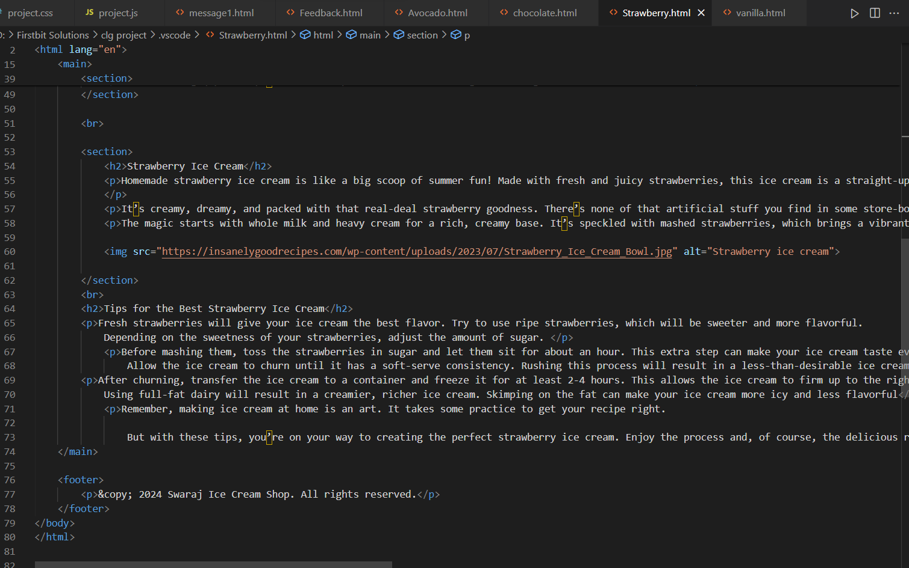

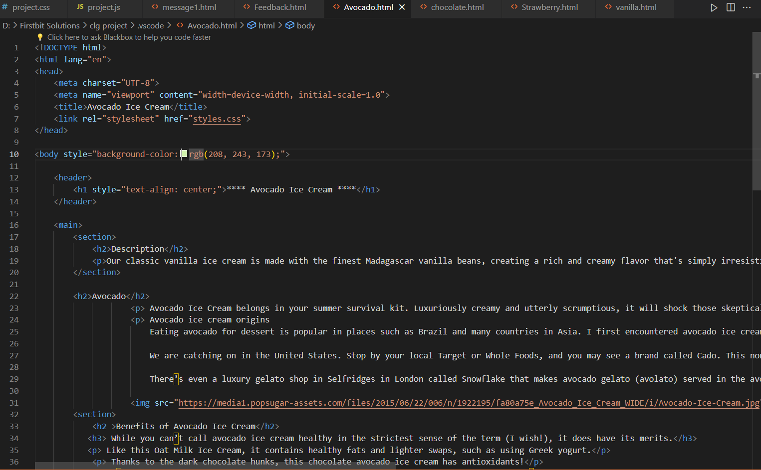

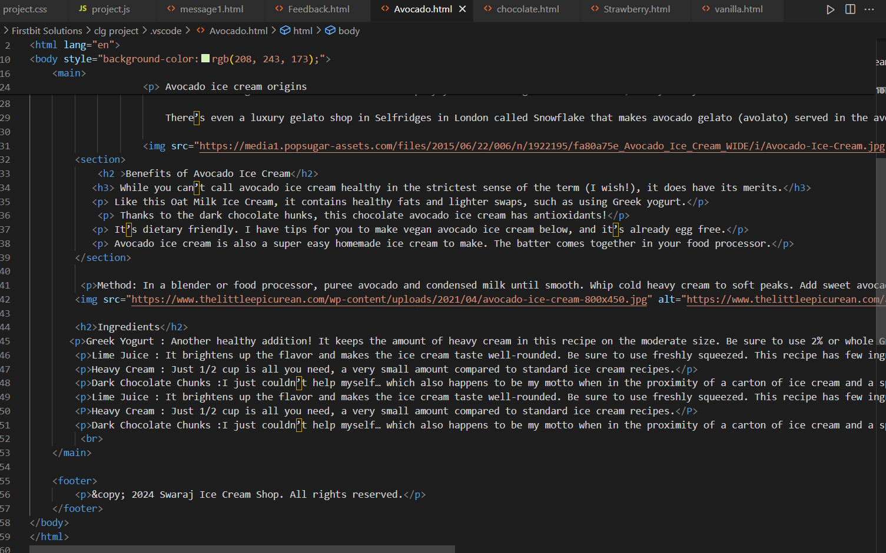

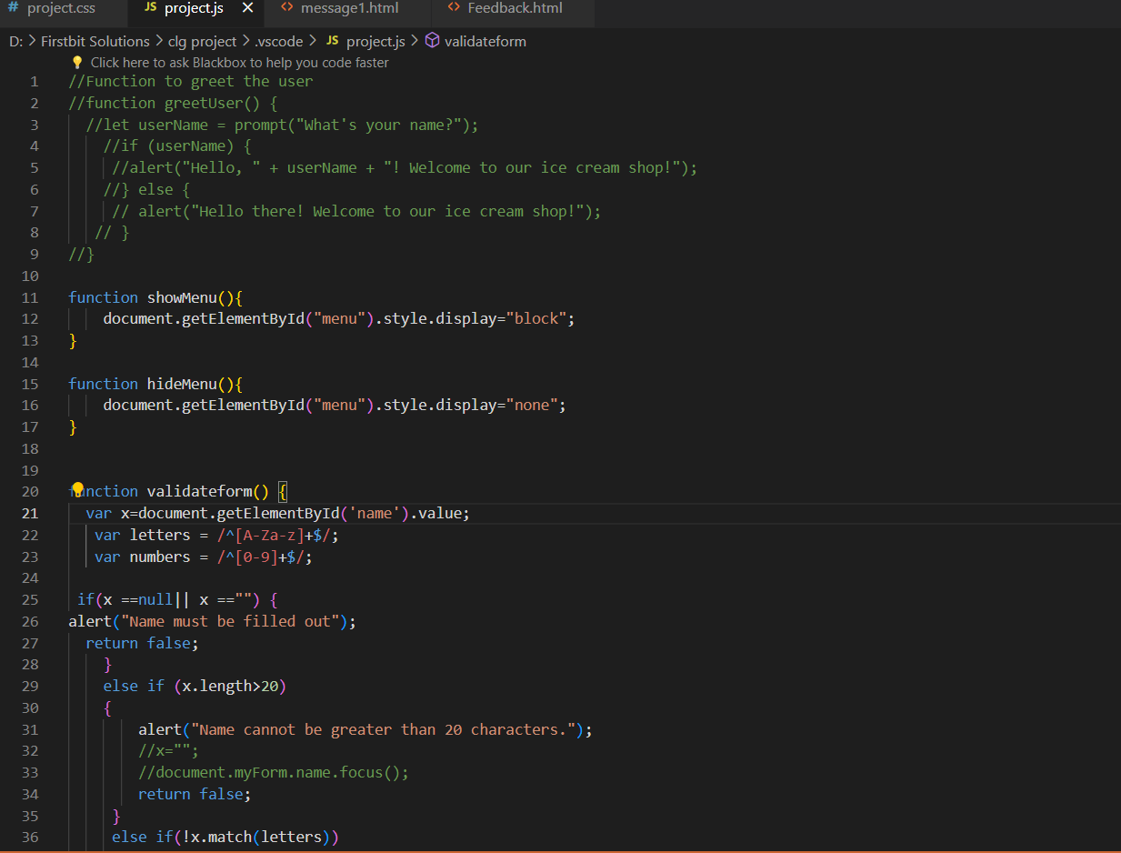

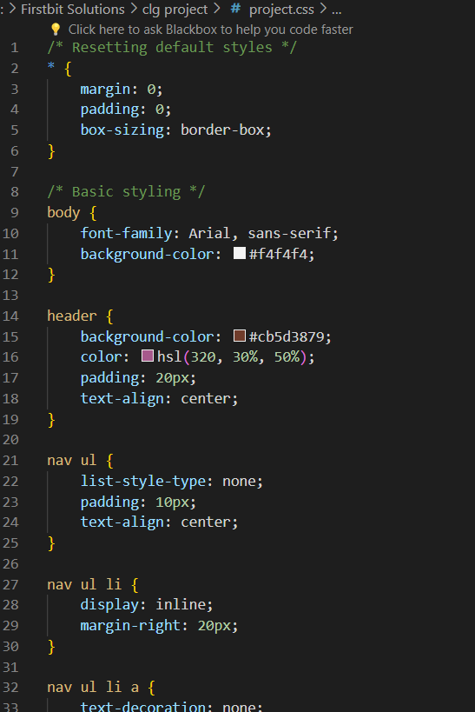

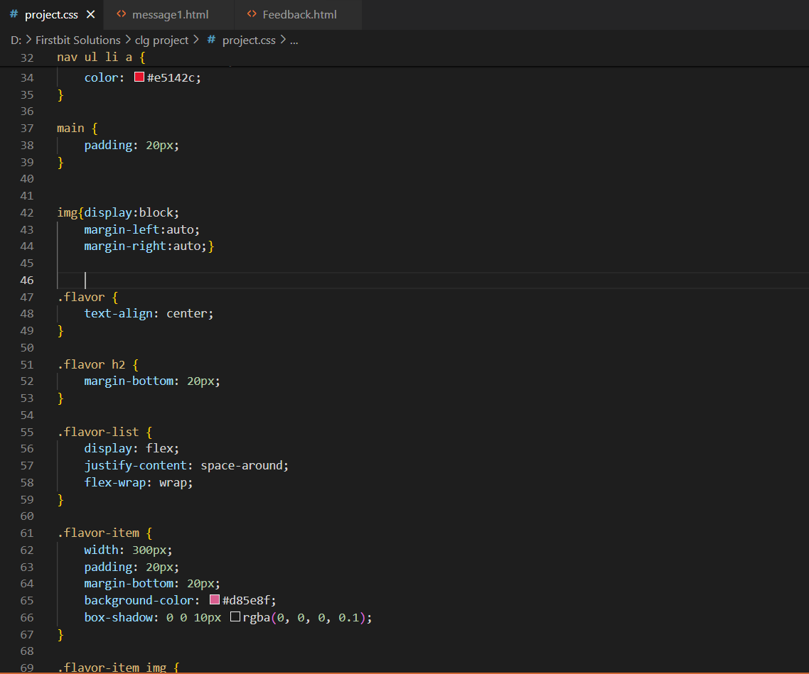

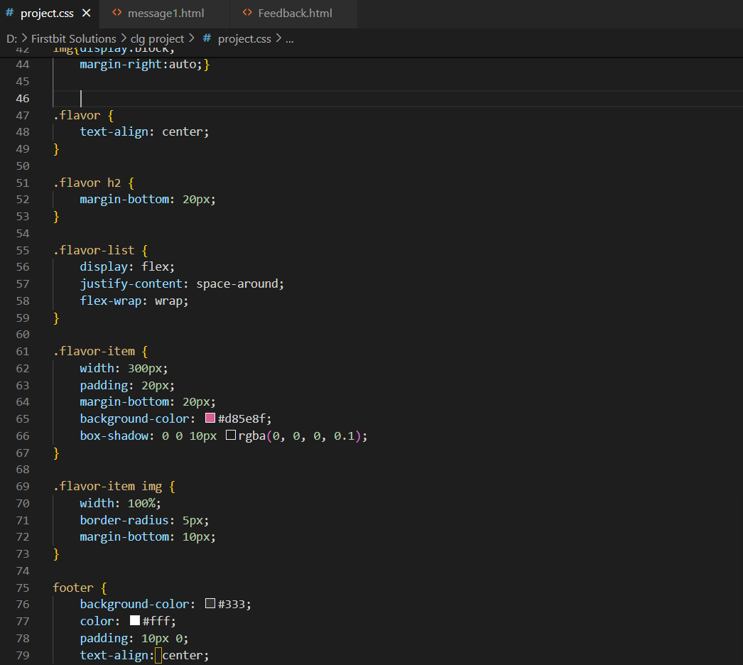

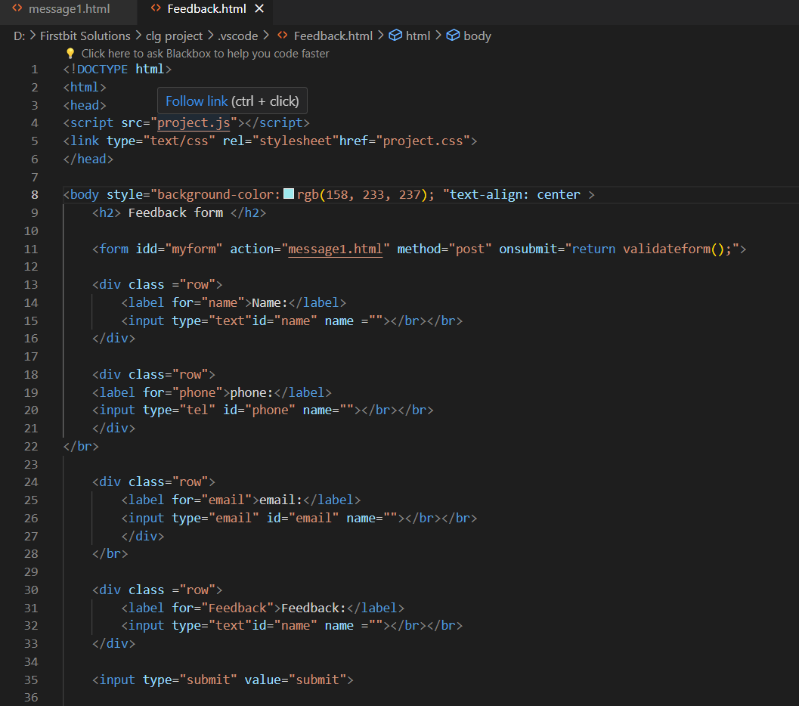

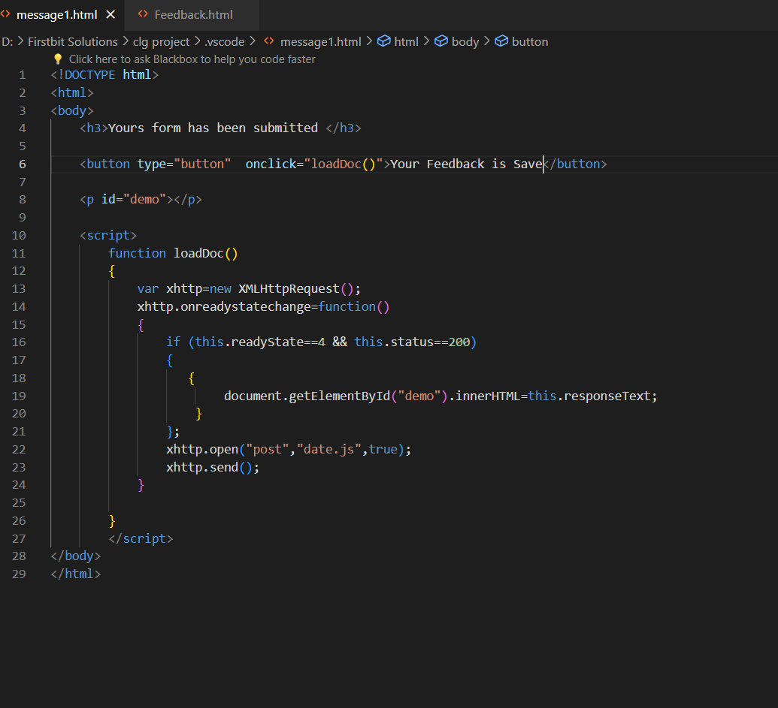

**Bibliography**

Here's a bibliography for the code provided:

HTML (Hypertext Markup Language)

MDN Web Docs. (n.d.). HTML: Hypertext Markup Language. Retrieved from https://developer.mozilla.org/en-US/docs/Web/HTML

CSS (Cascading Style Sheets)

MDN Web Docs. (n.d.). CSS: Cascading Style Sheets. Retrieved from https://developer.mozilla.org/en-US/docs/Web/CSS

JavaScript

MDN Web Docs. (n.d.). JavaScript. Retrieved from https://developer.mozilla.org/en-US/docs/Web/JavaScript

THANK YOU